**SECTION 4**

1. It is calculating confidence level of our assumed hypothesis against the alternative hypothesis,(hypothesis correct or wrong).Types- t-Test, chi-square test, ANOVA, HOV, Mood’s median, Normality etc.
2. Correlation is the study of relationship between two population, variables or samples. Either it can be linear or non-linear.
3. Some methods to calculate the correlation between variables were,
4. Scatter diagram method,
5. Spearman’s rank correlation coefficient method,
6. Karl pearson’s coefficient of correlation,
7. Methods of least squares.
8. P-value is the probability value which gives us the probability of the null hypothesis being true, e.g. if p-value of 0.01 represents high chance of rejecting null hypothesis, it is usually obtained from hypothesis testing.
9. Given n=23,
10. Mean= 45.65217, Variance= 62.60079, Standard deviation= 7.912066

Empirical distribution plot

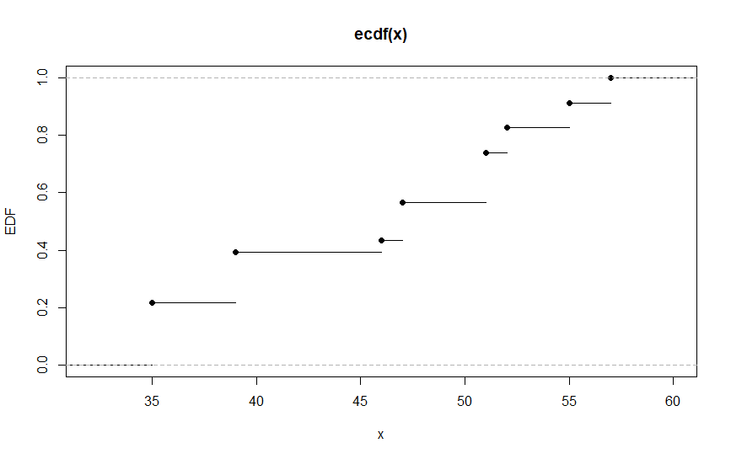

1. Quantiles

25% 50% 75%

39.0 47.0 51.5

Median – 47.

(NOTE: All calculations are done in R studio)

(CODE

A <- c(55,55,46,47,47,47,35,35,35,35,35,39,39,39,39,57,57,51,51,51,51,52,52)

sort(A, partial = NULL, na.last = NA, decreasing = FALSE)

is.unsorted(A, na.rm = FALSE)

print(mean(A))

print(var(A))

print(sd(A))

y <-count(A)

print(y)

ecdf(A)

plot(A,plot.ecdf(A), ylab="EDF",xlab="n",verticals = FALSE,

col.01line = "gray70", pch = 19)

quantile(A,c(.25,.50,.75))

print(median(A)) )

1. n=10
2. Mean= 173.1, Variance= 678.7667
3. 95% confidence interval lies between 156.9524 and 189.2476

(NOTE: All values are calculated using R studio)

(CODE:

A <- c(165,199,180,169,195,194,176,164,181,108)

B <-mean(A)

print(B)

print(var(A))

S <-sd(A)

n <-10

error <- qnorm(0.975)*S/sqrt(n) #for 95% CI the z value is 0.975

left <- B-error

print(left)

right <- B+error

print(right)

)